IMDB Movies
Capstone Project Analysis Report (PRSQL-01)
Prepared by: Sauravi Sarode
Batch / Team: PTID-CDA-SEP-26-11277
Date: 06-10-2026

1. Introduction

1.1 Objective
This project analyzes a movie industry dataset to answer 13 specific business questions using SQL, and extends the analysis into an interactive Power BI dashboard covering popularity, profitability, ratings, and director-level diversity and performance.

1.2 Dataset Overview
Source: MySQL database - project_movie_database, Tables: movies, directors
- movies table: 47 records (budget, revenue, popularity, vote_average, vote_count, release_date, director_id, etc.)
- directors table: 2,349 records (name, gender, department) - a broad reference list of directors, of whom only a subset are linked to the 47 movies in this dataset

1.3 Tools Used
- MySQL - data querying and the 13 required problem queries
- Power BI - dashboard and chart visualization
- Microsoft Word / PDF – reporting

Power BI - dashboard and chart visualization

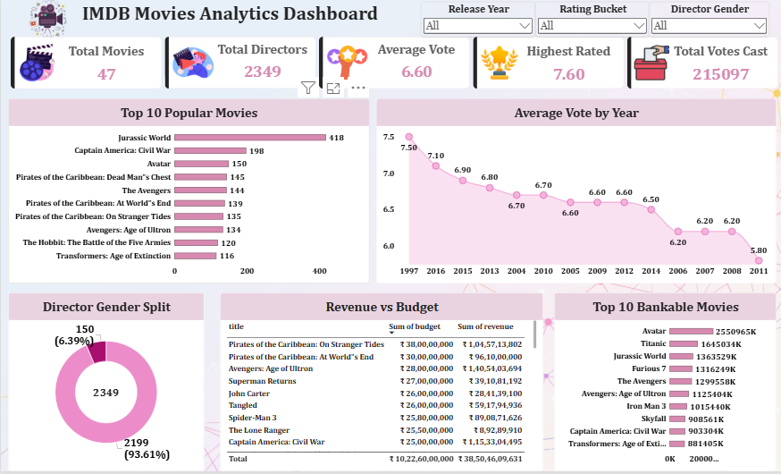

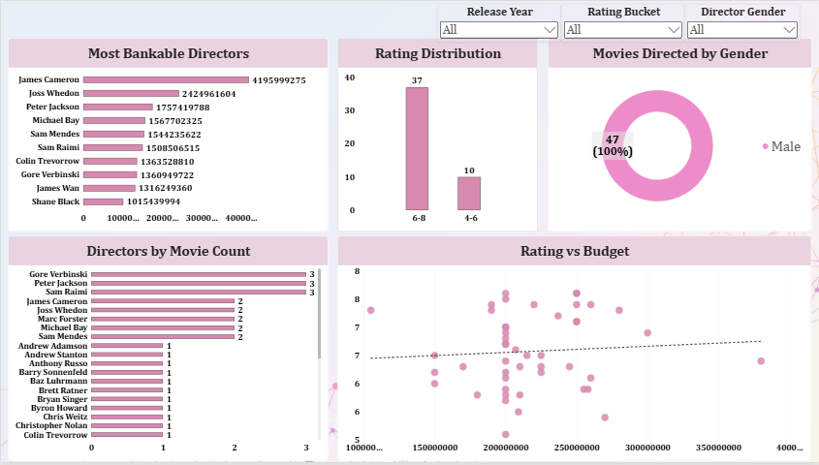

2. Key Performance Indicators (KPIs)
Total Movies  47 | Total Directors  2,349 | Average Vote  6.60 | Highest Rated  7.60 | Total Votes Cast  215,097

Female Directors  150 (6.39%) | Male Directors  2,199 (93.61%) | Movies by Female Directors  0 (0%)

2.1 Supporting Notes
Total Movies and Total Directors are counts of all records in each respective table. Average Vote and Total Votes Cast are calculated across all 47 movies. The gender KPIs are calculated two ways deliberately: director-level (what share of all 2,349 directors on file are women - 6.39%) versus movie-level (what share of the 47 movies in this dataset were actually directed by a woman - 0%). These two numbers tell very different stories and are both reported below.

3. SQL Query Answers Summary
Full queries and screenshots for all 13 required questions are provided in the attached SQL query document. Summary of key answers:

Q1-Q2 | Retrieve all movie / director data | 47 movie records, 2,349 director records
Q3 | Total number of movies | 47
Q4 | Find James Cameron, Luc Besson, John Woo | All 3 found (Department: Directing)
Q5 | Directors with name starting with S | List retrieved (see SQL doc)
Q6 | Count of female directors | 150
Q7 | 10th female director (by ID order) | Angelina Jolie
Q8 | 3 most popular movies | Jurassic World (418), Captain America: Civil War (198), Avatar (150)
Q9 | 3 most bankable movies (by profit) | Avatar ($2.55B), Titanic ($1.65B), Jurassic World ($1.36B)
Q10 | Highest average vote since Jan 1, 2000 | The Dark Knight Rises (2012) - 7.6
Q11 | Movie(s) directed by Brenda Chapman | None found in this dataset
Q12 | Director with the most movies | 3-way tie: Gore Verbinski, Sam Raimi, Peter Jackson (3 each)
Q13 | Most bankable director (total profit) | James Cameron - $4.196B total profit (2 movies)

4. Charts & Visualizations

4.1 Top 10 Popular Movies (Bar Chart)
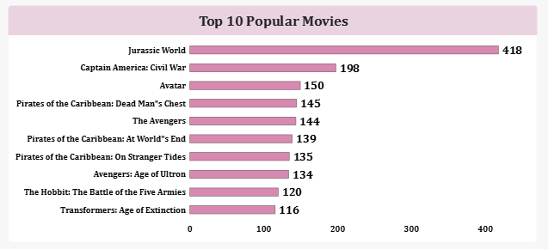
Insight: Jurassic World is by far the most popular movie (418), more than double the second-place Captain America: Civil War (198). Avatar (150) rounds out the top 3, matching the SQL answer to Q8. Three Pirates of the Caribbean films and two Avengers films appear in the top 10, suggesting franchise sequels dominate popularity in this dataset.

4.2 Average Vote by Year (Line Chart)
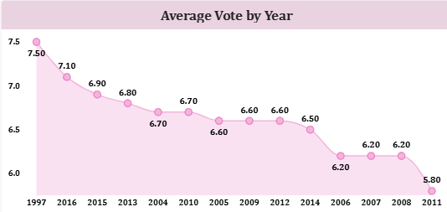
Insight: Average ratings across the years in this dataset range from 5.80 (2011) to 7.50 (1997). Note: the chart axis should be checked and sorted chronologically (ascending by year) before finalizing, as the current view may display years out of sequence. Once sorted, re-confirm whether ratings show a genuine trend over time or are simply noisy due to the small number of movies per year.

4.3 Director Gender Split (Donut Chart)
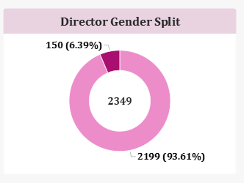

Insight: Of all 2,349 directors on file, 150 (6.39%) are female and 2,199 (93.61%) are male. This reflects the full reference list of directors, not just those whose movies appear in this dataset - see Section 4.8 for the more relevant movie-level breakdown.

4.4 Revenue vs Budget (Table)
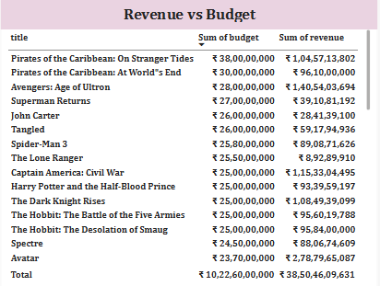
Insight: Across the sampled movies, Pirates of the Caribbean: On Stranger Tides (~$380M budget, ~$1.05B revenue) and Captain America: Civil War (~$250M budget, ~$1.15B revenue) show strong returns. In contrast, Superman Returns and The Lone Ranger stand out as the weakest performers - The Lone Ranger in particular spent roughly $255M but returned only about $89M, a loss of over $165M.

4.5 Top 10 Bankable Movies (Bar Chart)
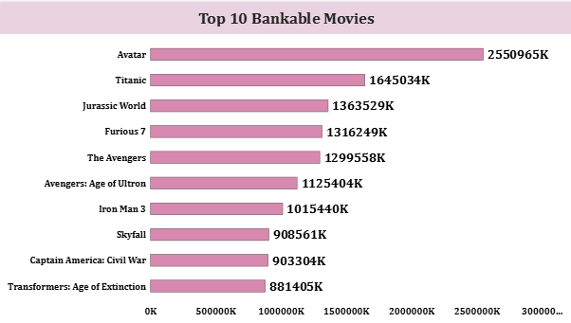
Insight: By profit (revenue minus budget), Avatar leads overwhelmingly at $2.55B, followed by Titanic ($1.65B) and Jurassic World ($1.36B) - confirming the SQL answer to Q9. Notably, these are not the same as the most popular movies list (Section 4.1), except for Jurassic World and Avatar, which appear on both.

4.6 Most Bankable Directors (Bar Chart)
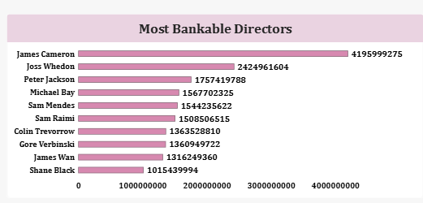
Insight: James Cameron leads with $4.196B in total profit from just 2 movies (Avatar and Titanic), nearly double second-place Joss Whedon ($2.42B). This confirms the SQL answer to Q13 and highlights that total bankability is driven more by a small number of massive hits than by directing many movies - James Cameron ranks #1 in profit despite not appearing in the top of the "most movies directed" list.

4.7 Rating Distribution (Column Chart)

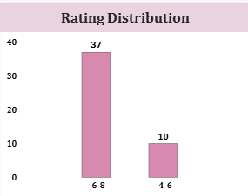
Insight: 37 of the 47 movies (79%) fall in the 6-8 rating band, and the remaining 10 (21%) fall in the 4-6 band. No movies in this dataset rate below 4 or above 8 - ratings are concentrated in a fairly narrow, above-average range, with no true outliers in either direction.

4.8 Movies Directed by Gender (Donut Chart)
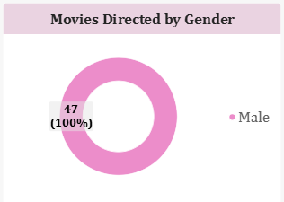
Insight: All 47 movies (100%) in this dataset were directed by men. Despite 150 female directors existing in the broader directors reference table (6.39% of all directors), none of them directed any of the 47 films actually analyzed here - consistent with Q11, where the female director Brenda Chapman returned zero linked movies. This is the single most significant diversity finding in the dataset.

4.9 Directors by Movie Count (Bar Chart)
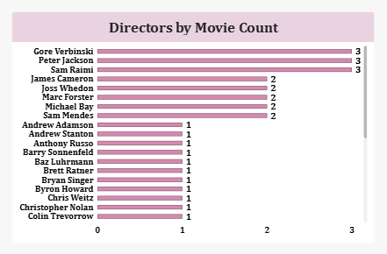
Insight: Three directors are tied for the most movies in the dataset, each with 3: Gore Verbinski, Sam Raimi, and Peter Jackson - confirming the SQL answer to Q12. Five more directors (James Cameron, Joss Whedon, Marc Forster, Michael Bay, Sam Mendes) each directed 2 movies, and the remainder directed just 1 each.

4.10 Rating vs Budget (Scatter Chart)
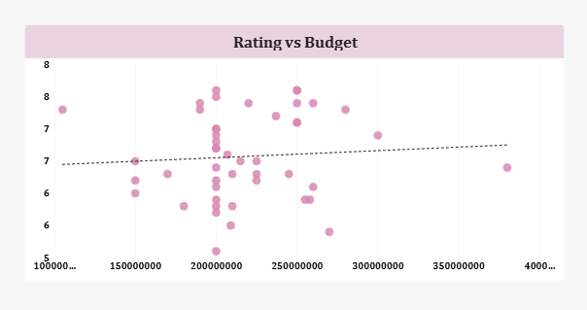
Insight: The trend line across budget vs. vote_average is nearly flat, with only a very slight upward slope. This indicates that a bigger budget does not reliably produce a better-rated movie in this dataset - high and low ratings both occur across the full range of budgets from roughly $100M to $380M.

5. Insights & Findings

5.1 Popularity vs Profitability
The most popular movies (by popularity score) and the most bankable movies (by profit) are mostly different lists - only Avatar and Jurassic World appear on both. Popularity and profitability should be treated as distinct signals, not proxies for one another.

5.2 Director Diversity - A Major Gap
While 6.39% of all directors on file are women, 0% of the 47 movies in this dataset were directed by a woman. This is a far more severe gap at the movie level than the director reference list alone suggests, and is the standout finding of this analysis.

5.3 Budget Does Not Guarantee Success
Both the Revenue vs Budget table and the Rating vs Budget scatter chart point the same direction: spending more does not reliably produce either higher ratings or higher revenue. The Lone Ranger and Superman Returns are clear examples of high budgets that did not pay off, while Spider-Man 3 and On Stranger Tides show strong returns at similar budget levels.

5.4 A Small Number of Hits Drive Most Profit
James Cameron's total profit ($4.196B) comes from just 2 movies, more than any other director achieved across 2-3 films. This shows that bankability in this dataset is concentrated in a handful of blockbuster hits rather than spread evenly across prolific directors.

5.5 Ratings Are Consistently Above Average
Every movie in the dataset rated between 4 and 8, with no movie below 4.0, and the overwhelming majority (79%) rating 6.0-8.0. This suggests the dataset may already be pre-filtered toward notable, widely-released films rather than a fully random sample of all movies.

6. Recommendations
- Investigate the zero female-directed movies finding: with 150 female directors on file but none linked to any of the 47 movies analyzed, recommend reviewing whether this dataset under-samples female-directed films, or whether it reflects a genuine historical gap worth highlighting separately.
- Use profit, not popularity, when evaluating financial success: since the most popular movies and most bankable movies are largely different lists, recommend tracking both metrics separately in any future greenlighting or investment decisions.
- Treat high-budget projects with added scrutiny: The Lone Ranger and Superman Returns show that large budgets carry real downside risk. Recommend a case-study review of what distinguished these underperformers from similarly-budgeted successes like On Stranger Tides.
- Study James Cameron's model for high-profit, low-volume filmmaking: his 2-movie, $4.2B profit record outperforms directors with 2-3x as many films. Recommend documenting what made Avatar and Titanic exceptional as a reference case.
- Fix the Average Vote by Year chart's axis sort before final submission: the year axis should display in chronological order for the trend to be interpretable at a glance.

